Address Changes done in Website

MEDIVO HEALTHCARE PRIVATE LIMITED
E-49, 8D Office, New Roshan Pura Extension, Hanuman Mandir, Najafgarh, South West Delhi, 110043

Removed this: -
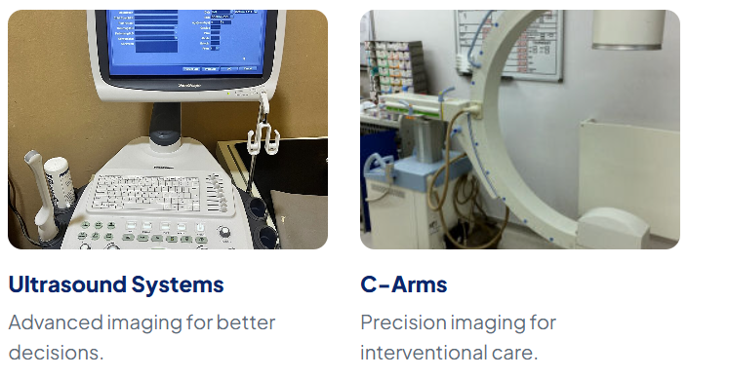

Removed from the website: -

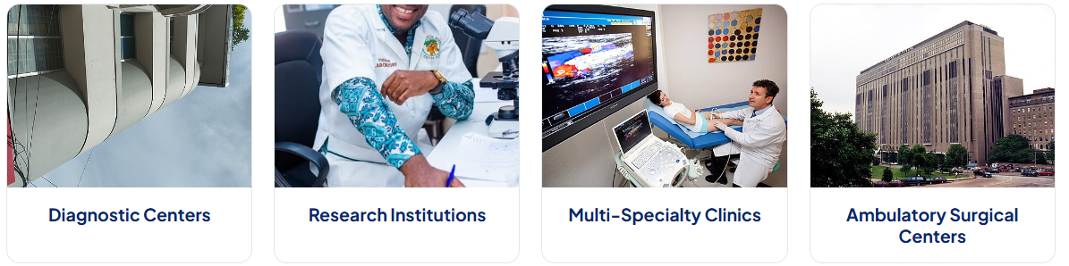
Removed from the website: -
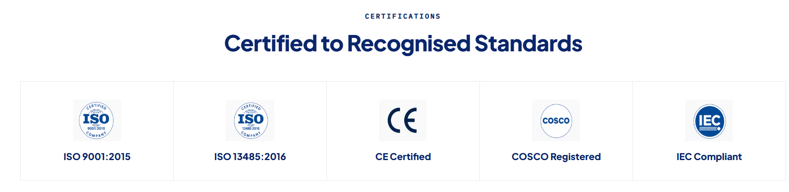
Removed from the website: -
Products to add on the Website: -
- MRI Pulse Oximeter

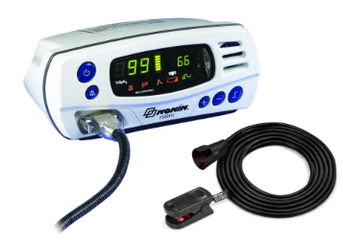

- MRI Patient Trolley

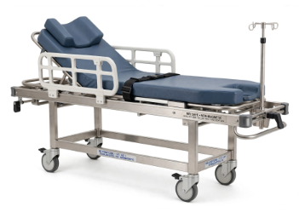
- Lead Glass
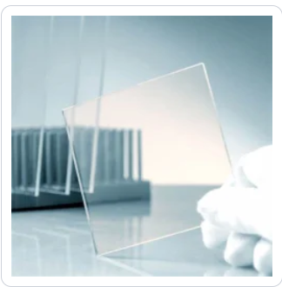

- MRI Wheelchair
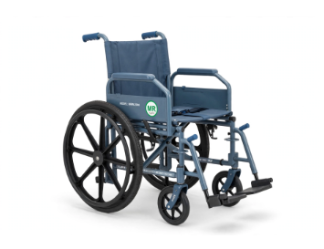

- Consumables
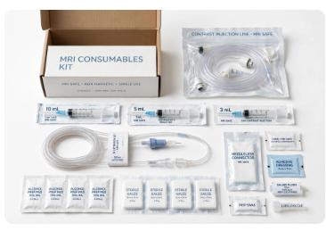
- CCTV Accessories
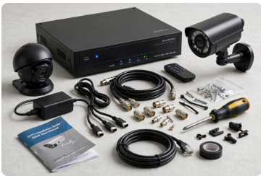
- Single and dual Head Injector
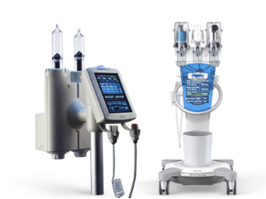

X Ray Chest Stand

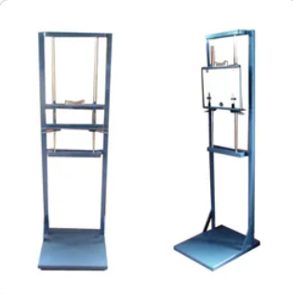

Lead Aprons (skirt And Vest)



Lead Aprons (Double Sided)

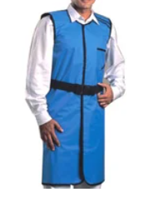

Lead Aprons (Coat Apron)

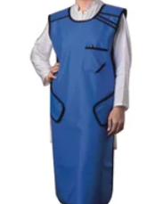

Gonad Shield
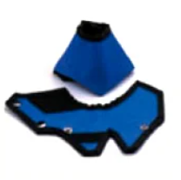
Thyroid Shield

Pressure Injector Syringes
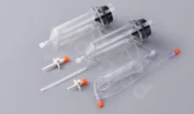

Walk-through Door Frame Metal Detector (DFMD)Handheld Metal Detector:-
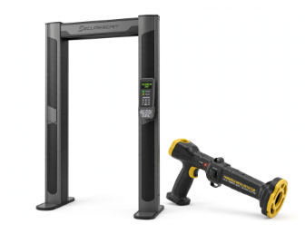
In-bore experience
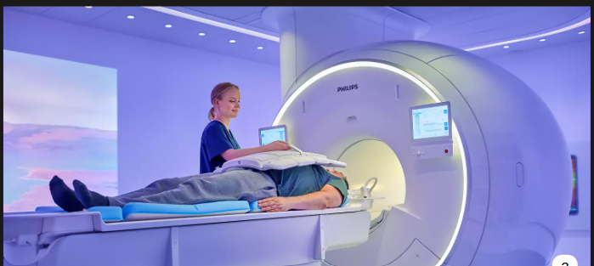
MRI Compatible Oxygen Cylinder
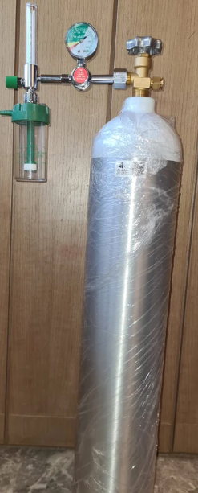
MRI Mobile I.V Stand
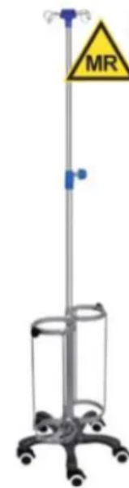
ABS MRI Trolley
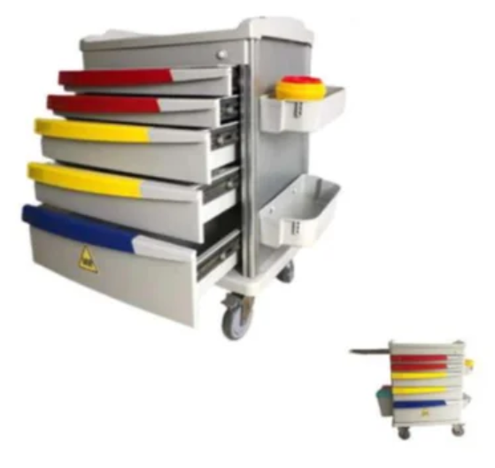
Hand Held Metal Detector
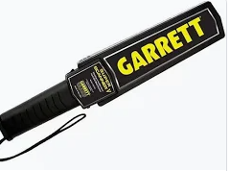
MRI Instrument Trolley
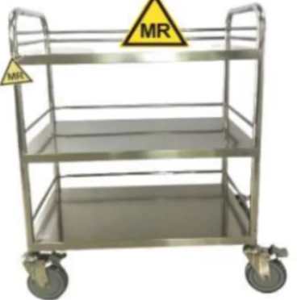

Barco medical-grade monitors
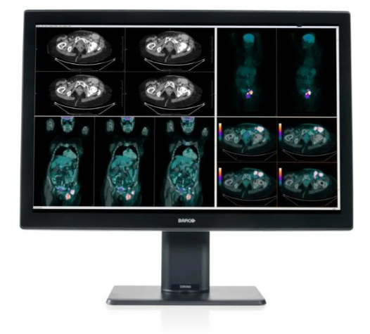
RF Cage
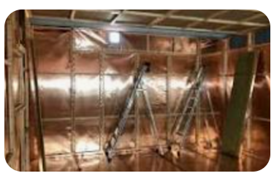
MRI/CT/PET CT - Sky Light Ceiling Work
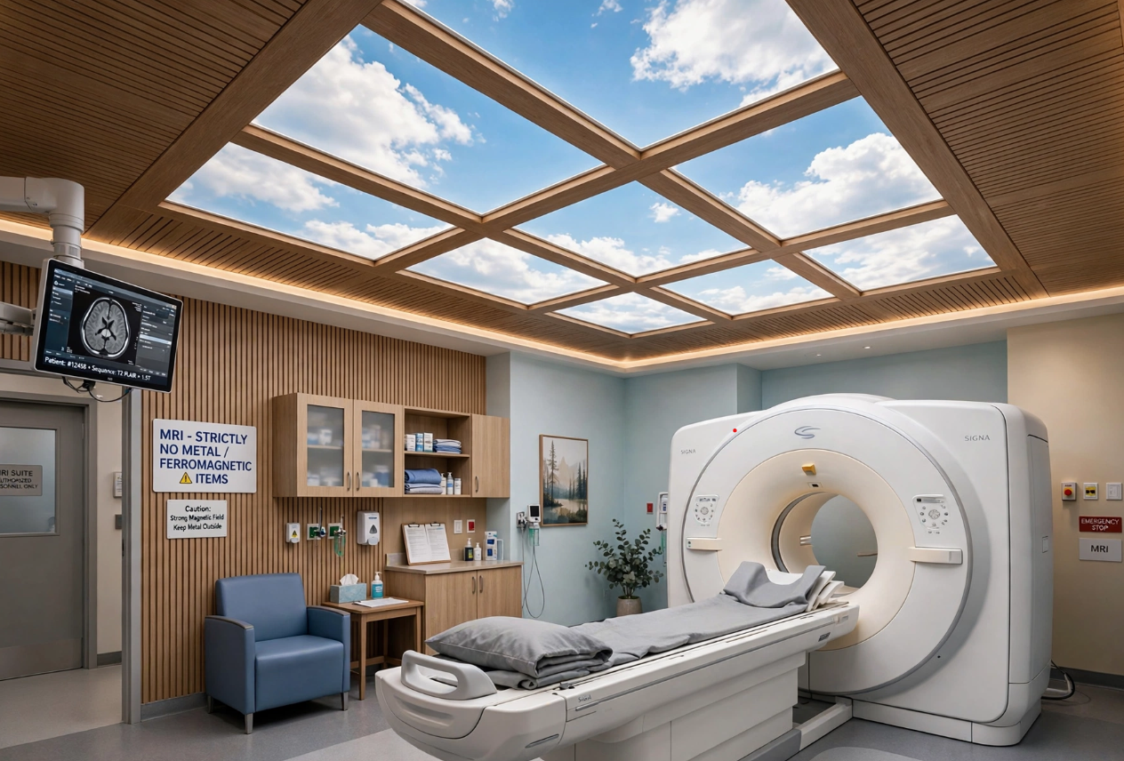
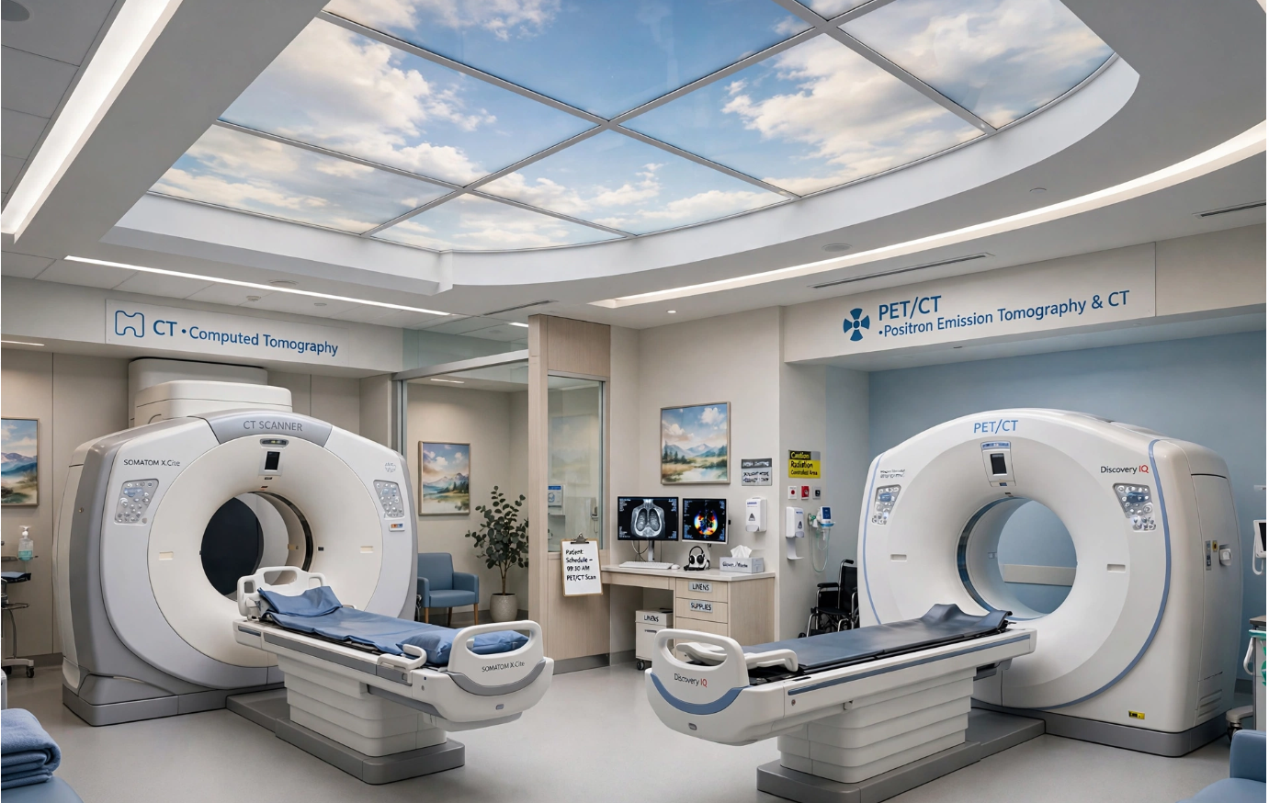
Services: -
- MRI/CT/PET-CT/ Installation: - Complete installation, calibration and commissioning of MRI, CT & PET-CT systems.
- Quench Pipe services and Installation and supplies: Supply and installation of MRI quench vent pipe, cryogenic venting, outdoor exhaust termination as per safety norms.
- MRI/CT/PET-CT Unloading: - Safe unloading of heavy imaging equipment with crane, forklift, manpower and shifting to site.

